25/04/2019 Jackie
- package "parser" is created.
- "Main" is renamed as "SmellDetect"
- class "CompilationUnitMap" is created, in the class:
- the .java files in the file the user uploaded are parsed into a list of compilation unit
- every list of compilation unit is stored into a hash map called compilationUnit, the key is the session ID of that user, value is the list of CU which belongs to the user
- List of compilation unit is stored into the hash map at the end of “ZipDecompservlet”, and is forwarded to the test.jsp.
- test.jsp displays the content of the compilation unit

28/04/2019 Jackie
- Classes “FileBase” and “CompilationUnitMap” deleted
- Classes “UserBase” and “UserInfo” added
- UserInfo: stores zipped file address, unzipped file address, compilation unit, names of all the java files, java source code
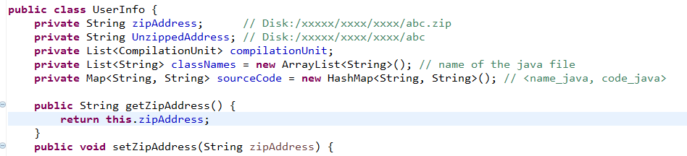
- UserBase: a hash map with session ID as key, an object of UserInfo as value. A model stores all the users.
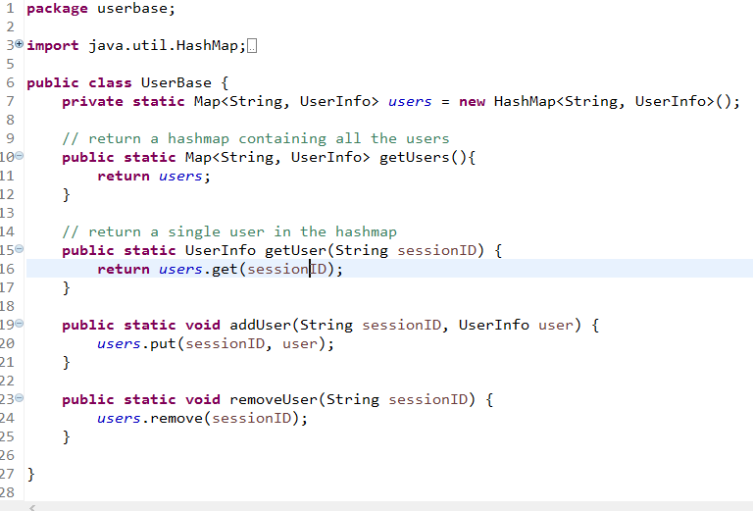
- Servlets “PageOnloadServlet” and “SourceCodeServlet” added
- PageOnloadServlet: after user uploads his file, “result.html” will request this servlet while loading the page. The servlet returns the source code of the first java file stored on the server which belongs to that user and an array of names of all the java files. Source code is used by “result.html” to display on the page, and names of java files are used to set selector.
- “SourceCodeServlet”: Every time user select a java file’s name in the selector on page “result.html”, a request will be sent to this servlet. Source code corresponding to the name that the user selected will be returned to the page to be displayed.
- Dynamic selector is applied in “result.html”. When the page is loading, options of the selector are created base on the response of “PageOnloadServlet”, i.e. number of options, names.
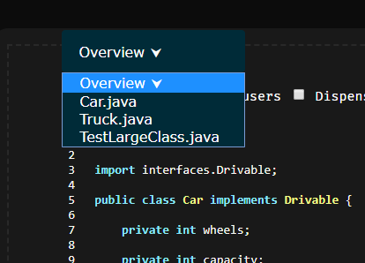
- Source code highlighter and line number are available for every source code returned by the “SourceCodeServlet”

